Operations Management Plan: Al Rahji Bank
Name
Institution

Part 1
Description of the Industry
The kingdom of Saudi Arabia is made up of thirteen licensed domestic banks. The financial system of Saudi Arabia is made up of Saudi Arabia’s central bank also known as the Saudi Arabia Monetary Authority (SAMA), private investment institutions, specialized lenders and the Stock market (Assaf, Barros, & Matousek, 2011).. The role of the central bank is to manage monetary policy, regulate banks and financial institutions and oversee insurance policies. The government owns less than 10 percent of the commercial banks to ensure monetary flow and good funding initiatives. Al Rahji Bank is among the largest banking companies based in Saudi Arabia.
PESTEL Analysis
On this paper, the analysis will be done using PESTEL Analysis. On the political matter, the bank is subjected to political fluctuations and uncertainties. The company has several branches strategically distributed among the cities. Political instabilities in any of these towns would affect the banking operations. The economic aspect focuses on the role of the bank to the Kingdom’s economic system. Most of the bank’s consumers are locals involved in the oil production business. The current fluctuations in price and demand for oil are a threat to Al Rahji Bank. Socially, the company has focused on empowering women alongside the several corporate social responsibility activities it is involved with on a day to day basis. Al Rahji has launched several health and educational initiatives for the community. The bank has an innovative technological system that focuses on customer satisfaction. The company has advocated for environmental conservation through digitization. Finally, the bank takes part in legal matters and liquidation decisions in line with Shariah laws.
In summary, the Bank has is accountable to the government, its scope of operations is dependent on the current political and governmental rules. It is also evident that the bank is at the mercies of the economic tides, that is inflation rates are likely to affect the profitability. Technology is helping the bank keep better track of their data while the consumers are able to access the bank services online. Legally, the bank is considerate of the consumer laws and there are rules set in place to protect customer data and transactions.
Description of the Company
The bank was founded in 1967 by four brothers; it started as a group of banking and financial operations and later merged to form the Al Rahji Trading and Exchange Company in 1978. It has been involved in several operations including stock exchange before it finally narrowed into a banking and investment corporation (Assaf, Barros, & Matousek, 2011).. Al Rahji Bank is an active trader in the Saudi Arabian Stock Exchange market, and the public owns 75 percent of the shares. The biggest shareholder for this bank is the Al Rahji family. The bank recently expanded its services beyond the Saudi Arabian borders by launching its operations in Malaysia. Al Rahji Bank partnered with the Ministry of Housing in 2016, an effort that is aimed at increasing homeownership by offering mortgages to the consumers. The bank has also increased the scope of its operations by focusing on the small and medium enterprises in collaboration with the government to push forward the social reform agenda.
Competitor Analysis
Several competitors surround the bank in the market. HDFC is the bank’s most significant rival with exceeding market penetration and followers in social media platforms. HDFC deals with personal and commercial banking services in the market. The bank also experiences competition from the Saudi Arabia British Bank, the Saudi Hollandi Bank, Riyadh Bank, and the Arab International Bank (Assaf, Barros, & Matousek, 2011).. These competitive forces in the market have led to innovations as a strategy to change the traditional banking system to accommodate more consumers.
Scope
The bank takes pride in its substantial efficiency and the high income generating capacity. Al Rahji bank has extended its operations into Malaysia in the attempts to go international. The bank ensures each of the branches experiences minimal operating costs; it is expected to improve on the cost-effective strategies to maximize income. The company reported a new net profit of 7.4 billion which is 1.4 billion higher than the closest rival. The bank deals with a wide range of Islamic services and products (Assaf, Barros, & Matousek, 2011). The company prides itself in the attention it receives on a national and international scale; the brand is recognized internationally.
The project parameters are as follows
- Project risks-No financial data available for use in the project
- Project quality-This project is more focused on the quantity of service offered than the quality aspects.
- The project is expected to take less than three months.
Objectives
Al Rahji’s vision is to become a trusted leader in delivery of innovative financial solutions that enhance the quality of life everywhere. The mission of the company aims at becoming the most successful and admired bank for the innovative services offered to the consumers, technological advancement and Sharia-compliant products globally (Assaf, Barros, & Matousek, 2011). The objectives for this operational management plan is :
- Improve customer service score and decrease the number of customer complaints
- Reduce customer wait time by improving the staffing plan
- Improve managerial operations
- Reduce employee turnover and provide training and wellness program.
Value Creation
Productivity and Effectiveness
Al Rahji Bank measures productivity by accessing the total output per unit of inputs used in the production of financial services. The bank offers the following services including credit department, deposits, trade of securities, investment advice, consumer financing, and remittances. A product is considered productive if it produces either a forecasted quantity of output will less input. This is an efficient way of measuring productivity in financial statements. The company should emphasize on other measures of productivity concerning the market share and the breakeven point. Unlike the usual measure, the later ensures the external environment of the business will be put into consideration.
Process Alignment
The organization utilizes the IT alignment in the banking process to enhance customer service and quality of their services (Hassoune, 2002). Al Rahji has an existing inter-organizational information system among the branches locally and internationally. The forefront business-oriented technology implemented in the bank is proving beneficial as expressed by the high returns to the firm.
Process Map
All the bank employees and management team have well-defined roles that suite their training and professional competence. Al Rahji’s process map is arranged in hierarchical order with the upper-level executives on the first places of the chain down to the front-line tellers.
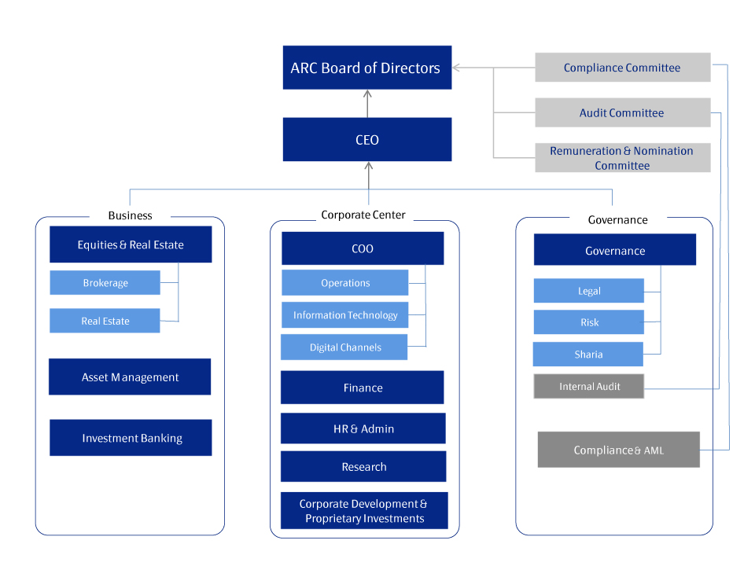
Process Description
The bank's processes are in the form of a chart flow diagram representing the flow of information and the order of information flow throughout the organization. The flowchart relates the to service delivery process to the customer’s perception and satisfaction.
Process Effectiveness
The mapping process is useful in that it has simplified the distance between the bank and the consumers. The bank can identify the population and flow of consumers in the various branches. The demographic characteristics of the consumers are available in the bank's system enabling the bank to measure its efficiency and make corrections in the places that require improvement. The management uses data gathered on the efficiency of each process in the flowchart to make decisions. Through the process, Al Rahji Bank can monitor the competitive advantage in the market place.
Process Recommendations
The bank should improve the efficiency of the process in relation to its potential. Greater efficiency can be achieved by coming up with a bigger platform for supplying the goods and services to the market. This will protect the company from operating at a competitive disadvantage. The bank can also reduce customer response time by reducing the decision-making process. The time and activities behind value creation should be analyzed by removal of non-value added tasks and time or reducing cycle times.
Inventory
Current Inventory Management System
Al Rahji Bank maintains an electronic inventory management system. The system facilitates data management in relation to the inflow and outflow of products and services from the organization. The inventory management process is handled by the management in order of first in first out method (FIFO) (Hassoune, 2002).. The supplies are received periodically as per the bank’s demand.

The effectiveness of the Inventory Management System
The inventory management system is capable in that it enables the bank to plan the activities and forecast on future expenditure patterns.
Recommendations
It is advisable for the bank to adopt mobile inventory management systems; this can be used by the management and the stock controllers to track stock movements and improve customer service. The mobile inventory system can be used to facilitate promotions and offers. Making the data accessible to store managers will lead to improved efficiency and encourage consumer purchase decisions.
Quality
The bank has a series of basic parameters used to measure the quality of service or performance. These measures include asset quality, capital adequacy ratio, liquidity ratios and estimation of the earnings throughout the branches. The most embraced measure of quality is the asset quality; assets play a crucial role in the day to operations. Assets give the impression that the loans portfolio amount is generating income for the bank (Hassoune, 2002). Generation of income is measured by the bank’s ability to pay off their loan interests on the working capital and elimination of non-working assets.
Costs of Quality
Preventative costs
These are the costs the bank strategically employs to design maintenance and implementation of the quality management system. The bank experiences these costs before the operations they are to perform. Al Rahja Bank experiences preventive costs in terms of quality planning costs, training of staff and stakeholders and provide requirements.
Appraisal Costs
These are the expenditures incurred during the quality monitoring procedures. The costs are related to customers and the company’s suppliers. The bank has measures in place to ensure the materials and services supplied to attain the required specifications. The costs are experienced in quality audits, supply ratings, verification, and investigation.
Internal Failure Costs
These are the costs incurred in relation to the quality of service offered to customers. The banking sector incurs these costs when a customer is dissatisfied with the services offered. They include rework and rectification of erroneous records and misinterpretation of customer information and failure analysis procedures within the organization.
External Failure Costs
Al Rahji Bank experiences costs related to defects realized by the customers. This means the bank has to remedy the process to ensure the company’s reputation is safeguarded. They include costs associated with return inwards and customer service.
Employee involvement in quality delivery
The bank ensures the employees have a sense of belonging alongside the professional competences. This strategy ensures the company operations run smoothly as the staff offer quality service to the consumers.
PART 11
Project Management
Al Rahji Bank has a project manager whose major roles include ensuring the projects are properly coordinated, implemented and completed. The projects are based on the bank’s short term and long term goals. A project is researched about, and it is the duty of the project manager to facilitate the feasibility of the plan and the approvals from supporting departments and the affected stakeholders (Hassoune, 2002). The projects are mostly aligned with the business strategies and the shareholder’s decisions
Work Break down Structure
The company’s work break sown structure indicates the logical breakdown of duties and processes required for the project to be successful. The organization is very specific on the period at which a project starts and the duration is taken for the actualization of the project. The financial department analyzes the cost tradeoffs by regulating the amount allocated to each project and encouraging frequent reporting during the project.
Measurement of Risks in projects
The bank uses statistical methods such as standard deviation to measure both systematic and unsystematic risks.
Location
Current Location
Al Rahji Bank is a family business; the location was chosen as a central point for the four brothers to interact and exchange their ideas as well as ensure a steady market for their services. The strategic placement of the headquarters ensures the company attracts customers from the oil production business around alongside foreign investors (Hassoune, 2002).. The location is effective for the performance of the bank operations considering the many branches distributed in major towns in Saudi Arabia. There is no recommendation for a suitable location; the bank is strategically placed to meet the needs of the consumers
Layout
The facility’s layout is effective in that it supports a smooth and steady flow of production and staff management at a minimum cost. The physical allocation of the headquarters makes it possible for the shareholders to hold long undisrupted meetings. It also acts as the representation of the company’s operations. The employees are arranged in systematic order in the branches with segments and departments owning their own private spaces.
ERP Software
The organization does not use the ERP software due to the nature of operations and the projects.
SWOT Analysis
Strengths
Al Rahji Bank has various successful operations that make the strengths; these aspects include the high levels of clientele retention. As noted the bank has several branches serving diverse consumers in the country (Zia, 2015). The bank has a functional online platform, low levels of staff turnover and a product line diversification.
Weaknesses
The bank has areas where it is falling short in terms of goal achievements. For instant, the decreasing rate of brand recognition due to the high competitive power in the industry (Hassoune, 2002). The higher loan rates due to lower interest rates maybe a problem for the bank in the long run; it may incur several bad debts
Opportunities
The bank has potential for growth; taking advantage of these opportunities will lead to increased productivity and business continuity. The growing Saudi –Arabian economy due to the increase in oil production is a big avenue for the bank to grow (Zia, 2015). The new high yield investment products such as incorporation of women banking can lead to higher incomes to the bank. With the current international expansion plans, the company is likely to receive higher saving rates from the diverse clientele.
Threats
According to recent reports, the bank is likely to be harmed by the increased capital gains in the taxation system due to the increased export trading. The other threat is the increasing rate of competitors in the market and the increasing rate of insurance premiums for financial institutions.
Final Recommendations
The bank has the potential for growth and globalization in the near future, for that to be attainable it is advisable for it to be flexible to changes in the structure of operations with specific attention to the Islamic banking laws. Al Rahji Bank should consider other avenues other than the Shariah-compliant services so as to enable easy market penetration in other countries that are not entirely dominated by the Islam community. The availability of an indigenous pool of labor with the required industry-relevant knowledge might be a challenge if the organization remains inclined on one path of production.
The bank should also increase the marketing strategies to avoid being wiped out of the market by the competitors. These marketing strategies should incorporate promotional campaigns in social media platforms and around the branches. They should aim at increasing the flow of consumers for the goods and services. Market penetration strategies should be considered before the bank opens a branch in a new town so as to ensure their products fit into the market alongside the substitutes, alternatives and competitors.
The bank needs to rearrange the organizational structure to accommodate the junior staff teams alongside the executive members. This gives the stuff a sense of belonging and increases the customer’s lifespan in the bank. They should come up with new customer loyalty initiatives other than the smart cards or offer better quality to customers to keep the customers interested in the services.
Conclusion
In conclusion, Al Rahji Bank is in a financially viable path. The opportunities for growth and globalization are vast and available given the highly qualified professional team and the efficiency of the project management body. Provision of training for staff and more marketing strategies need to be put in place to ensure business continuity and productivity in the local and international markets.

References
Assaf, A. G., Barros, C. P., & Matousek, R. (2011). Technical efficiency in Saudi banks. Expert Systems with Applications, 38(5), 5781-5786.
Hassoune, A. (2002). Islamic banks’ profitability in an interest rate cycle. International journal of Islamic financial services, 4(2), 1-13.
Zia, A. (2015). Transformational Leadership a Study of Banking Sector in Saudi Arabia. Global Journal of Management And Business Research.

